

**EXTERNAL INTERGRATED SUMMATIVE ASSESSMENT**

**Quality Controller, NQF4**

|  |  |
| --- | --- |
| **STUDENT NAME & SURNAME** |  |
| **IDENTITY NUMB ER** |  |
| **ASSESSMENT CENTRE** |  |
| **ACCREDITATION NUMBER** |  |
| **QUALIFICATION** | **QUALITY CONTROLLER** |
| **QAQA ID** | **117309** |
| **NQF LEVEL** | **4** |
| **CREDITS** | **173** |
| **PAPER NUMBER** | **2A** |
| **DATE OF EISA DD/MM/YYYY** |  |
| **DURATION** | **2 HOURS** |
| **TOTAL MARKS** | **100** |

**EXTERNAL INTEGRATED SUMMATIVE ASSESSMENT**

**QUALITY CONTROLLER**

**QUESTION PAPER 2A**

**GENERAL EISA RULES**

**1. Students are only allowed to use the supplied EISA booklets.**

**2. Students are only allowed to use a black pen for their answers.**

**3. Students to ensure that their name, surname and EISA registration number appears on the front of your EISA booklet.**

**4. This is a closed book examination; therefore, no other material or belongings are to be brought into the assessment centre. Should you bring any other material or belongings into the assessment centre, you will be required to leave such at the front of the assessment centre examination room. The assessment centre will not be held liable for any loss or damage to property brought into the assessment centre examination room.**

**5. All EISA booklets must be handed back to the invigilator intact. No pages may be torn off from the EISA booklet. The removal of EISA booklets from the examination room is prohibited.**

**6. Students may make use of a calculator in this EISA.**

**7. Unless this is an online examination where access to a computer will be made available to you; the use of any communication devices, including smart watches, cell phones, tablets, iPads, headphones and laptops are prohibited.**

**8. All cell phones are to be switched off for the duration of the EISA.**

**9. The invigilator will not assist you with the explanation of questions related to the EISA.**

**10. Students are prohibited from conversing in any manner with other students.**

**11. Students may not leave the examination venue within one hour of the start of the examination and in the last 10 minutes of the allotted examination period.**

**12. Students who are found to be disruptive and unruly in the assessment centre will be requested to leave the assessment centre by the invigilator.**

**I HEREBY CONFIRM THAT I HAVE READ THE ABOVE EISA RULES AND DECLARE THAT I**

**UNDERSTAND AND ACCEPT THE RULES.**

**________________________**

**SIGNATURE OF STUDENT**

**CANDIDATE INSTRUCTIONS**

* **Candidate must complete all question s in the EISA**
* **Candidates must ensure that they use only a black pen when completing this EISA.**
* **Should you require additional space to complete your answer, please request additional paper from your invigilator.**
* **Ensure that you indicate your name, surname and EISA registration number at the top of the additional paper.**
* **Also ensure that the question number is clearly marked on your additional paper.**

**-----------------------------------------------------------------------------------------------------------------**

ur Sayzwani Abd Suki;Elmi Abu Bakar ,Shahrul Kamaruddin/ A Case Study on Improvement of Outgoing Quality Control Works for Manufacturing

Products 4(1), pp. 12-21, 2015

**Question 1.1**

* + 1. Identify deviations, non-conformance (internal) and risks (internal and external stakeholders)

**(15 Marks)**

|  |
| --- |
| 1.1.1 Case Study  Allocate three marks for number 1 and twelve marks for number 2  Use discretion to allocate marks for any other relevant point that may be given by the student. |

Case Study:

Company ‘A’ strives to be very competitive company, however continuous customer complaints due to poor service and product failure are the **main** challenges. An analysis must be conducted to determine if the product/service meet the desired specifications and also to determine if the product parameters are still within specifications.

|  |  |  |
| --- | --- | --- |
| **Number** | **Question and Answer** | **Marks** |
| 1 | Define Deviation and give an industry example | 3 |
| 2 | A deviation is an unplanned event and can be caused by many factors, List and discuss 6 factors which may cause deviation to occur. | 12 |
| **Total** | | **15** |

* + 1. **Investigate the root cause of the deviation, non-conformance (internal) and risks (internal and external stakeholders) using a relevant technique e.g fishbone diagram, 5 why’s root cause analysis**

**(15 Marks)**

|  |
| --- |
| 1.1.2 Case Study  Allocate ten marks for number 1 and five marks for number 2  Use discretion to allocate marks for any other relevant point that may be given by the student. |

|  |  |  |
| --- | --- | --- |
| **Number** | **Question and Answer** | **Marks** |
| 1 | Explain how will go about finding a root cause for problems experienced by company ‘A’ in the case study above and list the 6 symptoms to look out for when conducting a root cause analysis | 10 |
| 2 | Draw and label the fish bone technique | 5 |
| **Total** | | **15** |

**1.1.3 Develop alternative solutions (recommendations) for identified deviations and non-conformances**

**(10 Marks)**

|  |
| --- |
| 1.1.3 Constructive Response  Allocate ten marks each for number 1  Use discretion to allocate marks for any other relevant point that may be given by the student. |

|  |  |  |
| --- | --- | --- |
| **Number** | **Question and Answer** | **Marks** |
| 1 | Once a problem has been found, solution must be found. The best way will be to develop best alternative solutions for identified deviations and non-conformances.  Discuss in details either 1 of the 2 brainstorming techniques used to find alternatives solutions. | 10 |
| **Total** | | **10** |

**1.1.4 Implement corrective actions to address deviations and non-conformances**

**(10 Marks)**

|  |
| --- |
| 1.1.4 Constructive Response  Allocate ten marks each for number 1  Use discretion to allocate marks for any other relevant point that may be given by the student. |

|  |  |  |
| --- | --- | --- |
| **Number** | **Question and Answer** | **Marks** |
| 1 | Corrective action is usually taken when there are deviations of processes and or product /services from specifications.  Discuss the implications of recommending inappropriate recommendation/s for both production and service industry | 10 |
| **Total** | | **10** |

**Question 1.2**

* + 1. Identify the components of the quality policy with regards to the safety, environment and legal compliance of product/service

**(10 Marks)**

|  |
| --- |
| 1.2.1 True or False  Allocate one mark each for number 1 to 10  Use discretion to allocate marks for any other relevant point that may be given by the student. |

|  |  |  |  |
| --- | --- | --- | --- |
| **Number** | **Statement** | **True/False** | **Marks** |
| 1 | Different industries and professions have compliance regulatory organisations supported by legislation. |  | 1 |
| 2 | It is not always important to ensure that correct processes are followed to keep business compliant. |  | 1 |
| 3 | Compliance to the Occupational Health and Safety Act measures may result in the loss of production. |  | 1 |
| 4 | It is important to note that the implementation of a quality management system is not a legal requirement. |  | 1 |
| 5 | Personal protective equipment (PPE) is not the main source of protection for emergency and recovery workers. |  | 1 |
| 6 | Depending on the hazard, the recommendations on the use of PPE change. |  | 1 |
| 7 | Effective [housekeeping](https://www.sfceurope.com/uk/job-roles/cleaner-housekeeping-staff) can help control and even eliminate potential workplace hazards to ensure safety throughout the working day. |  | 1 |
| 8 | The Occupational Health and Safety Act requires employers to have a Health and Safety Policy in place. |  | 1 |
| 9 | In the workplace an employees can work under the influence of liquor as that may not affect the quality of work. |  | 1 |
| 10 | Firms can use green approaches to address concerns about the natural environment. |  | 1 |
| **Total** | | | **10** |

* + 1. Apply procedures to maintain safety environment, legal compliance and quality of service or products.

**(20 Marks)**

|  |
| --- |
| 1.2.2 Constructive Response  Allocate ten marks for number 1, six marks for number 2 and four marks for number 3  se discretion to allocate marks for any other relevant point that may be given by the student. |

Having Health and Safety Policies & Procedures shows that employers, management and employees prioritize health and safety. It also indicates the commitment to reduce or remove risks, safe guard the safety and welfare of premises users. This includes contractors, visitors and anyone else who could be associated with the business. Answer the following questions below:

|  |  |  |
| --- | --- | --- |
| **Number** | **Questions and Answers** | **Marks** |
| 1 | Discuss the 5 responsibilities a manager has with regard to the health and safety procedure. | 10 |
| 2 | Discuss the 3 major types of a standard operating procedures and how they are used in an industry | 6 |
| 3. | Discuss what is meant by an organisation to be being socially responsible with regard to maintaining safety environment. | 4 |
| **Total** | | **20** |

* + 1. Identify and report non-conformance, risks and ensuring effective segregation.

**(20 Marks)**

|  |
| --- |
| 1.2.3 Case study  Allocate nine marks for number 1, eight marks for number 2 and three marks for number 3  se discretion to allocate marks for any other relevant point that may be given by the student. |

Conformance to quality is the degree to which a good or service meets certain design standards determined by the producer. In other words, it is a measure of how close products and services come to meeting planned criteria once they are produced or delivered. On the other hand, non-conformance is when something (a product, service, process or system) fails to conform to your agreed standard. Effective segregation and proper labelling of non-conforming products is required in order to ensure that there is no cross contamination as well the use of nonconforming products. The picture below is a typical illustration of segregation in the workplace.

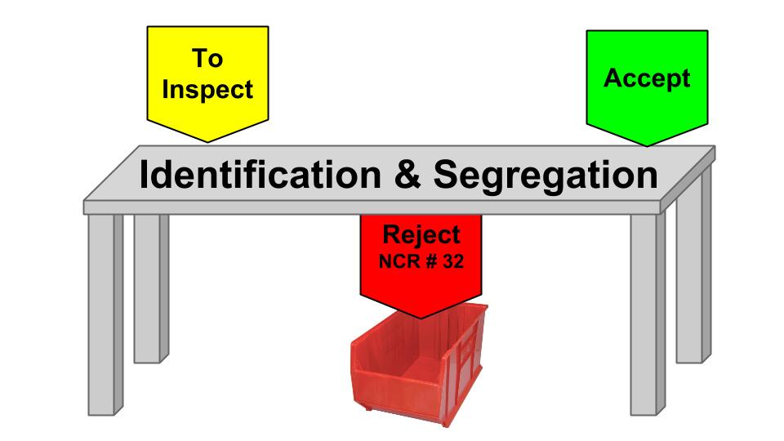

|  |  |  |
| --- | --- | --- |
| **Number** | **Questions and Answers** | **Marks** |
| 1 | Discuss the main types of audit and give one industry example | 9 |
| 2 | Discuss the 4 types of non- conformances and give one industry example | 8 |
| 3. | Discuss what is meant by effective segregation. | 3 |
| **Total** | | **20** |

**Marks Allocation Grid (For use by Assessor Only)**

|  |  |  |
| --- | --- | --- |
| **Question** | **Marks** | **Allocated Marks** |
| 1.1.1 | 15 |  |
| 1.1.2 | 15 |  |
| 1.1.3 | 10 |  |
| 1.1.4 | 10 |  |
| **Total Question 1.1** | **50** |  |
| 2.1.1 | 10 |  |
| 2.1.2 | 20 |  |
| 2.1.3 | 20 |  |
| **Total Question 2.1** | **50** |  |

**Assessor Details**

|  |  |
| --- | --- |
| **Assessor Name and Surname** |  |
| **Registration Number** |  |
| **Signature** |  |
| **Date** |  |

**Moderator Details**

|  |  |
| --- | --- |
| **Moderator Name and Surname** |  |
| **Registration Number** |  |
| **Signature** |  |
| **Date** |  |